**Exercises for Practical 7**

1. Create the employee table as below and copy the insert statement provided to insert the records.

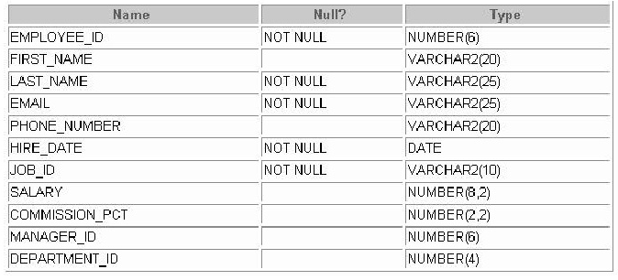

insert into employee values(141, 'Trenna','King','TRAJS','6501218009',to_date('17-OCT-1995','dd-MON-YYYY'),'ST_CLERK',3500,null,124,50);

insert into employee values(142,'Curtis','Loren','CLOREN','6501212994',to_date('29-JAN-1997','dd-MON-YYYY'),'ST_CLERK',3100,null,124,50);

insert into employee values(149,'Eleni','Grant','EGRANT','65012155922',to_date('29-JAN-2000','dd-MON-YYYY'),'SA_MAN',10500,.2,100,80);

insert into employee values(174,'Abel','Ellen','AELL','65012553251',to_date('11-MAY-1996','dd-MON-YYYY'),'SA_REP',1100,.3,149,80);

insert into employee values(176,'Jonathan','Taylor','JTAYLOR','3215456654',to_date('24-MAR-1998','dd-MON-YYYY'),'SA_REP',8600,.2,149,80);

insert into employee values(178,'Kimberly','Grant','Kgrant','4556621455',to_date('24-MAY-1999','dd-MON-YYYY'),'SA_REP',7000,.15,149, null);

1. Once you complete the above steps, write the sql select statement for each of the questions below:-
2. Show all data of the programmers who have been hired after the year 1997.
3. Show the last name, job, salary, and commission of those employees who earn commission. Sort the data by the salary in descending order.
4. Show the employees that have no commission with a 10% raise in their salary (round off the salaries).
5. Show the last names of all employees together with the number of years that they have been employed.
6. Show those employees that have a name starting withJ,K,L, orM.
7. Show all employees, and indicate with “ Yes” or “ No” whether they receive a commission.
8. Show all employees who were hired in the first half of the month (before the 16th of the month).
9. Show the names, salaries, and the number of dollars (in thousand s) that all employees earn.
10. Create an anniversary overview based on the hire date of the employees. Sort the anniveraries in ascending order.